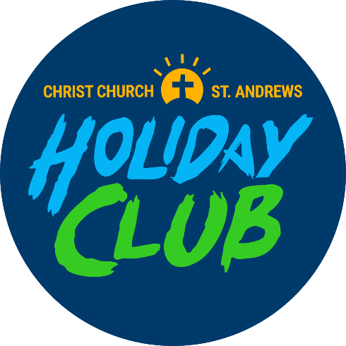
Holiday Club
Registration Form
August 11th – 13th 2025

We are delighted to announce that we will be running a Holiday Club from 11th – 13th August in Christ Church Christian Centre (the hall at Christ Church) for 5 – 11-year-olds. This event is free and will run from 9.30am – 12noon from Monday – Wednesday.
If you would like your children to come, the best way to sign up is by filling out one of these forms for each child and emailing them to vicar@parishofhernebay.org.uk, or alternatively TEXT Anthony Everrett on 07599608041 with the information requested on the sign up form. We are looking forward to a great holiday club!
Please note that the minimum age for those attending the holiday club are children who have finished their reception year and will be going up to year 1 in September.
Please note that drop off for the Holiday club is at 9.30am at the back entrance to Christ Church through the glass doors at the end of the alley way on William Street, with collection at 12noon. This is a free event run by Christ Church St Andrews with bible-based activities, games and teaching. For any further information please contact Anthony Everett on the above email address, though note, the phone number is only reachable via TEXT message.

Child’s details

Name: _______________________________________

D.O.B _______________________________________

Address: _______________________________________

Allergies: _______________________________________

Medical conditions/medication:
____________________________________________________
____________________________________________________
Parent/Guardian details

Name: ______________________________________

Contact no. _______________________________________

Address: _______________________________________

Emergency contact

Name: ______________________________________

Contact no. ______________________________________

Disclaimer: No image of your children will be taken, though pictures of activities and games may be taken, but never with faces visible.
All Christ Church St Andrews volunteers have completed safeguarding training and are authorised to work with children. Fully qualified first aiders will be present for the duration of the Holiday Club

